Apartment Finder

( Team Members: Kasi Viswanath Vandanapu, Misha Mody)

We have divided the project into the following sub-projects:

* [@Kasi Viswanath Vandanapu](https://hci-neu.slack.com/team/U041DKC7BC5) will be working towards how the project can enable the user to filter apartments more and more specifically to his needs
* [@Misha Mody](https://hci-neu.slack.com/team/U041A0MH0TG) will be working towards how the user can add his notes, prioritize it and how the project can work on improving the search results for the user.

## 1. Design Brief

| Project Description | The project aims at improving the process of finding an apartment by letting users filter and search according to their specific needs. |
| --- | --- |
| Intent Scope | The scope is to reduce the search space for apartment finders and recommend apartments close to their needs.  By the usage of the platform, the needs are requirements of a user finding an apartment would be studied. |
| Exploration Questions | The project will explore key questions like:   1. What are the different filters a user wants to leverage during his apartment search? 2. What are some notes/tags the user wants to see regarding a certain apartment? 3. How can the entire process of searching for an apartment be streamlined and made easier? |
| Target Users | Renters, Realtors |
| Research Plan | We will identify the top 6 candidates for the interview and take a 40mins semi-structured interview session |
| Expected Outcomes | We expect to discover several opportunities for Apartment Finder to   1. Ensure the user finds the apartment based on the criteria that the user favors 2. Build a feature to add user personal notes/observations 3. Prioritize the apartments based on user interest |
| Success Metrics | 1. Did we discover an easier way for users to find the apartment? 2. Have we identified the design criteria that enable Apartment Finder to address these opportunities? |
| Project Planning | A 2-person full-time team will conduct the “exploration” phase over a 2-week period followed by prototype building |

## 2. User Stories

1. As a renter, Pavan wants to search for a 1-bedroom apartment with a price ranging closer to the average price of similar apartments, So he can find a budget-friendly apartment (Kasi Viswanath)
2. As a renter, Christin wants to prioritize her apartment search in Financial District, So she can stay near her company and reduce her travel (Kasi Viswanath)
3. As a renter, Albina wants to skip the apartments in the dangerous neighborhood area, So she can stay in a safer Neighborhood (Kasi Viswanath)
4. As a renter, Harry wants to look at apartments with a lease of fewer than 7 months, So he can move out based on his schedule (Kasi Viswanath)
5. As a renter, Pavan wants to search for a pet-friendly apartment, so that his dog can have facilities (Kasi Viswanath)

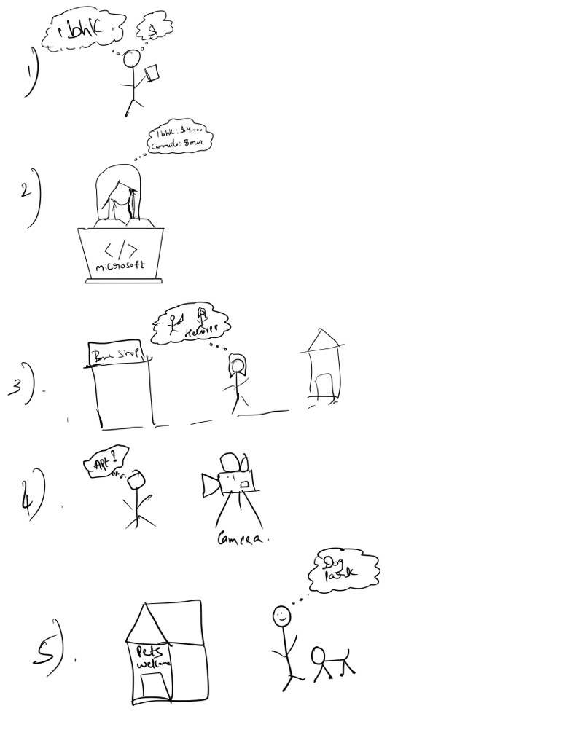

Sketches

1. As a realtor, Tim wants to only suggest apartments to his newly wed clients. Hence he filters apartments with the school location filter so that he can only suggest apartments that are actually close to a school district. ( Misha)
2. As a realtor, Jack realized the lease term is not mentioned on the house description, so he contacts the landlord and adds this information into the house descriptions so that he can personally annotate tags for the houses. (Misha)
3. As a renter, Zara realizes that the house has a rooftop swimming pool upon her visit, she adds this to the house description so that her observations are noted. (Misha)
4. As a realtor, Mike selects 5 houses that can be a perfect match for his clients, hence he adds each of them to his favorites so he can easily access them anytime. (Misha)
5. As a renter, Riya’s primary need is that she needs to find an apartment with a big swimming pool, hence she prioritizes her filters so that she can reduce her search by first viewing apartments with big swimming pools. (Misha)
6. As a realtor, Mark has been constantly viewing apartments for his clients. He annotates some of the apartments he visited by marking them as visited so that he is not suggested these apartments again in the future. (Misha)

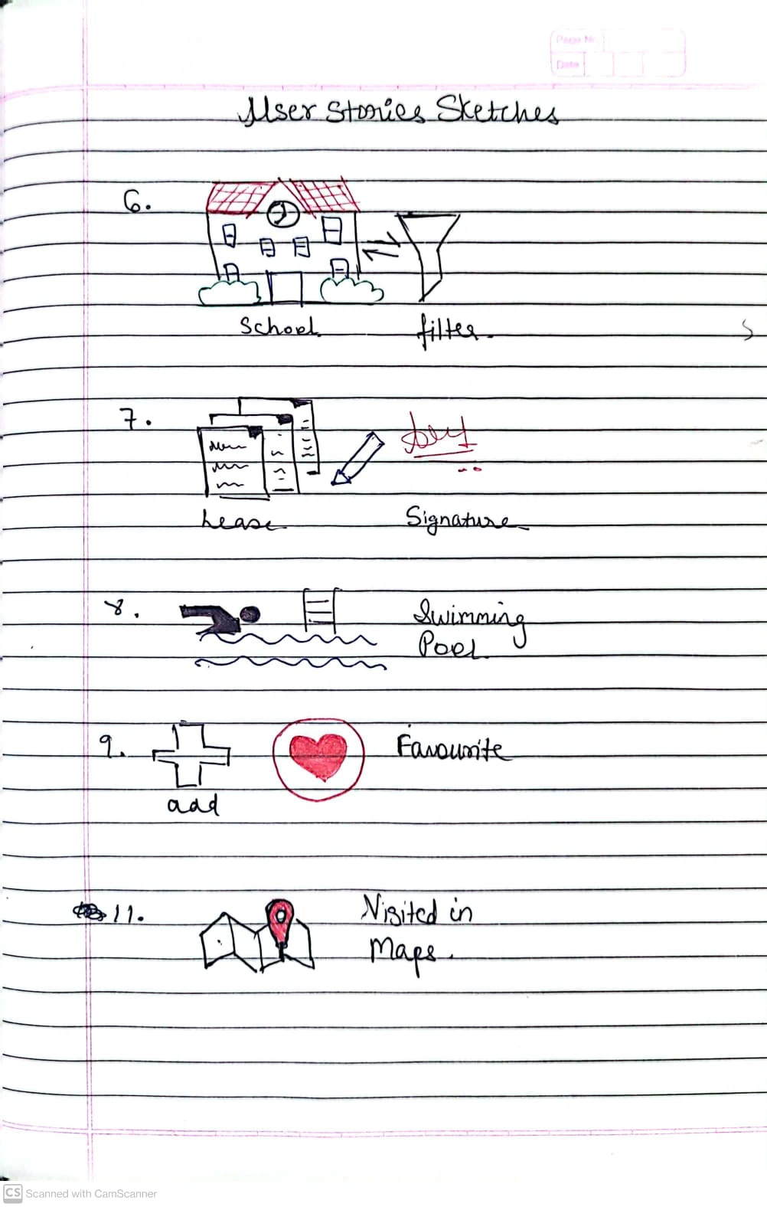

## 3. User Personas

1. Tim has been a realtor for 2 years. He is very tech savvy and uses online platforms to search for apartments he can suggest to his clients. He is approached by many couples who want to find apartments near to good school districts and hence he greatly benefits from the sorting by school district feature. (Misha)
2. Riya used to be a professional swimming coach and hence is looking for an apartment with a highly rated swimming pool. She wants to prioritize the swimming pool over other amenities and hence views such apartments with big swimming pools before the others. (Misha)
3. Mark has been living with a roommate for a few years now. He wants to move out to a new apartment nearby to his current roommate. Hence Mark wants to filter apartments close to his current location. (Misha)
4. Tara knows her current lease will end in a few months and is just casually browsing through apartments to see if she finds a better deal or wants to continue her current lease. Hence she marks some of the apartments she viewed as favorites. (Misha)
5. Pavan being a student and having a dog wants to reduce his rent. He wants to find a 1-bhk apartment for rent that is pet-friendly. Hence he is searching for budget-friendly and pet-friendly apartments (Kasi Viswanath)
6. Christin working as a software engineer at Microsoft wants to find an apartment closer to her office to reduce commute time and focus more on office work regardless of the rent (Kasi Viswanath)
7. Harry as an actor, is shooting for the show and wants to find an apartment with a lease of no longer than 7 months so that he can move out after his series shoot (Kasi Viswanath)
8. Albina as a single woman working the night shift from 3:00 pm - 1:00 am wants to search for an apartment in a safer neighborhood (not in Tenderloin) so that she can return safely at night (Kasi Viswanath)

## 4. Initial Assumptions

1. I assume that the renter can add the apartments to his favorites list (Kasi Viswanath)
2. I assume that the renter can prioritize the apartments based on metrics like the rent price area(sq. ft) of the apartment (Kasi Viswanath)
3. I assume that the renter can narrow down the apartment search based on his criteria like rent should be in the range of 3000-4000 USD, No smoking, and the apartment neighborhood is in the Financial District (Kasi Viswanath)
4. I assume that the renter can decide his choice of apartment based on the photos displayed (Kasi Viswanath)
5. Renters can add their own observations in terms of visits, lease starts, lease terms, etc. (Misha)
6. Renters can prioritize apartments based on either their customs annotations or existing tags. (Misha)
7. Renters can completely remove apartments having certain attributes from their search results based on locations, neighborhood, etc. (Misha)
8. Renters can dynamically use their current observations as filters to further such new apartments relating to that observation. (Misha)

## 5. Script:

First of all, thank you for taking the time to talk to us today. My name is Kasi Viswanath / Misha Mody and I am here to talk to you about your experience in searching for and finding an apartment using platforms like Craigslist, Apartments.com and realtor

Let me give you an outline of what’s going to happen. I am going to ask you a series

of questions. We want to understand things from your perspective. It’s important to

highlight that this isn't a test. There are no right or wrong answers to any of the

questions.

I would like to ask you to be as honest as possible. You can't offend me or anyone in any way so please speak freely. Do you have any questions or comments so far?

We treat this conversation as strictly confidential. We won't share any details with anyone outside the immediate people working on this project.

We can talk a lot quicker than we can type, would it be OK with you for us to record

this session for our note-taking?

We have prepared a consent form for you to review.

If at any point you want to take a break or stop the interview please just let us know

and we can work around it.

Any questions before we begin?

Let’s get started!

## 6.1 Questions (Misha)

1. Since how long have you been searching for a new apartment?
2. Why do you want to move into a new apartment?
3. What are ways you tried to search for a new apartment?
4. How much percent of your search has been through online portals?
5. What are some attributes you wish you could filter by in searching for an apartment?
6. Can you describe the entire process of logging into your computers, typing on the search box and viewing apartments?
7. What are some basic key descriptions you feel should definitely be included in an apartment posting?
8. If you came across a posting and realized some information was missing, would you go ahead and add that information if you had it?
9. In how many ways would you like to sort your search results?
10. What would an ideal apartment search process look like for you?

## 6.2 Questions (Kasi)

1. Where do you live currently? Can you describe more details of your current living apartment like rent, area, and neighborhoods around you?
2. What platforms have you used for finding this apartment? Which one suited you better?
3. Did you find any fake posts? How did you overcome it?
4. How many apartments have you shortlisted? Is the current apartment present in it?
5. What metrics you used to prioritize the shortlisted apartments?
6. What other details have you checked with the landlord before selecting this apartment?
7. How many apartments have you visited before selecting/picking this apartment?
8. Can you describe the process/ steps you used for finalizing this apartment?
9. Are you satisfied with your apartment search? (Rate from 1-5; 5 being the highest)
10. Do you still think you can find a better apartment? If so, what steps should be added that can help you to fill the gap?

## 7. Demographics

1. What is your age?
2. What are your personal pronouns?
3. Which neighborhood do you live in and why?
4. What is your native language?
5. How much rent are you paying currently?

## 8. **UNSIGNED CONSENT DOCUMENT**

**Northeastern University, Department of Khoury College of Computer Sciences**

**Name of Investigator(s**): **Kasi Viswanath Vandanapu, Misha Mody**

**Title of Project:** **Apartment Finder**

**Sponsor: N/A**

**Request to Participate in Research**

We would like to invite you to take part in a research project. The purpose of this research is to observe how users can search for a rented apartment, narrow down their results, and create observations/personal notes to refine the search and prioritize the apartment.

**\* You must be at least 18 years old** to be in this research project

The study will take place **via Zoom Recording Session** and will take about **40 Mins**. you decide to take part in this study, we will ask you **to answer a series of questions and discuss your opinions** about **apartment search**.

**There are no foreseeable risks or discomforts to you for taking part in this study.**

**There are no direct benefits to you for participating in the study.** However, your answers may help us to learn more about **Improving Apartment Search Process**

**Your part in this study will be handled in a confidential manner.** Only the researchers will know that you participated in this study. Any reports or publications based on this research will use only group data and will not identify you or any individual as being of this project.

**Future Use of Data or Biospecimens – This section should be included in the consent form per** [**46.116 (9) (i)**](https://www.ecfr.gov/cgi-bin/retrieveECFR?gp=&SID=83cd09e1c0f5c6937cd9d7513160fc3f&pitd=20180719&n=pt45.1.46&r=PART&ty=HTML#se45.1.46_1116)

Your de-identified information and/or biospecimens could be used for future research **without additional informed consent.**

**The decision to participate in this research project is up to you**. You do not have to participate and you can refuse to answer any question. Even if you begin the study, you may withdraw at any time.

**You will not be paid for your participation in this study.**

**If you have any questions about this study**, please feel free to call Kasi Viswanath (vandanapu.k@northeastern.edu) and Misha Mody (mody.mi@northeastern.edu) the person mainly responsible for the research.

**If you have any questions about your rights in this research**, you may contact Nan C. Regina, Director, Human Subject Research Protection, Mail Stop: 560-177, 360 Huntington Avenue, Northeastern University, Boston, MA 02115. Tel: 617.373.4588, Email: n.regina@northeastern.edu. You may call anonymously if you wish.

You may keep this form for yourself.

Thank you.

*Name of Investigator*

*1. Kasi Viswanath Vandanapu*

**2.** *Misha Mody*